A

PROJECT REPORT ON

Risk Management System

Submitted in partial fulfillment of the requirement
for the award of the degree of

BACHELOR OF TECHNOLOGY
IN
COMPUTER SCIENCE AND ENGINEERING

By:
Arun Gudepu (11P61A0509)
Rajat Dodle (11P61A0518)
Nikhil Gunda (11P61A0545)

Under the guidance of
Mrs. B.Manjulatha
Assistant Professor



VIGNANA BHARATHI INSTITUTE OF TECHNOLOGY
(Approved by AICTE, Affiliated to JNTU Hyderabad
Accredited by National Board of Accreditation (NBA), New Delhi)
Aushapur (V), Ghatkesar (M), R.R.Dist.

2015

(Approved by AICTE, Affiliated to JNTU Hyderabad
Accredited by National Board of Accreditation (NBA), New Delhi)

DEPARTMENT OF COMPUTER SCIENCE AND ENGINEERING

CERTIFICATE

This is to certify that the project report titled Risk Management System is being submitted by ARUN GUDEPU (11P61A0509), DEEPIKA MANNE (11P61A0515), NIKHIL GUNDA(11P61A0545) in B.Tech IV II semester Computer Science & Engineering is a record bona fide work carried out by them. The results embodied in this report have not been submitted to any other University for the award of any degree.

INTERNAL GUIDE HEAD OF THE DEPARTMENT
Mrs. B. MANJULATHA N.SRINIVAS

EXTERNAL EXAMINER

ACKNOWLEDGEMENT

Self-confidence, hard work, commitment and planning are essential to carry-out any task. Possessing these qualities is sheer waste, if an opportunity does not exist. So we whole-heartedly thank Dr. J. S. N. Murthy, Principal, Dr. N. Subhash Chandra, Director Academics and Mr. N. Srinivas, Head of the Department, Computer Science and Engineering for their encouragement and support and guidance in carrying out the project.
We thank our Project Guide, Mrs. B. MANJULATHA and external guide Mr. K. RAJASHEKARAM for providing us with an excellent project and guiding us in completing our project successfully.
We would also like to thank our project coordinator Mr. G. Srikanth Reddy for their valuable advice and suggestions from time to time and for being a constant source of inspiration to us.
We would also like to express our sincere thanks to all the staff of Computer Science and Engineering, VBIT, for their kind cooperation and timely help during the course of our project. Finally, we would like to thank our parents and friends who have always stood by us whenever we were in need of them.

Sincerely,
Arun Gudepu 11P61A0509
Deepika Manne 11P61A0515
Nikhl Gunda 11P61A0545

CONTENTS

Abstract …………………………………………………………………………....7

List of Figures
1. Content diagram of project……………………………………………………52
2. Usecase diagram………………………………………………………….…...46
3. Sequence diagram…………………………………………………………47-48
4. Class diagram…………………………………………………………………49

List of Tables
1. Design of test cases and scenarios…………………………………………69-71

List of Screens
1. Home page…………………………………………………………………….53
2. User pages…………………………………………………………….……53-57
3. Admin pages……………………………………………………………….58-63

Chapter 1

- INTRODUCTION
  - Motivation………………………………………………………….………9
  - Objective of Project………………………………………………………...9
  - Limitations of Project……………………………………………………..10

Chapter 2

- LITERATURE SURVEY
  - Introduction………………………………………………………………12
  - Existing System…………………………………………………………..12
  - Disadvantages of Existing system……………………………………….12
  - Proposed System………………………………………………………...13
  - Advantages of Proposed System………………………………………. 13
2.6 Conclusion…………..…………………………………………………14-28

Chapter 3

- Analysis
  - Feasibility study………………………………………………………30-31
  - System Requirement Specification
    - Software requirement………………………………………….31-32
    - Hardware requirement…………………………………………….32
  - Functional Requirements………………………………………………….32
  - Non-Functional Requirements…………………………………………33-34

Chapter 4

- DESIGN
  - Software design………………………………………………………..36-38
  - Input Design……………………………………………………………38-40
  - Output design………………………………………………………….40-41
  - UML diagrams…………………………………………….………......41-48

Chapter 5

- IMPLEMENTATION & RESULTS
  - Implementation of Proposed system……………………………………50-51
  - Modules…………………………………………………………………51-52
  - Method of Implementation
5.3.1 Output Screens……………………………………………………52-62

Chapter 6

- TESTING & VALIDATION
  - Introduction………………………………………………………………..64
  - Types of testing…………………………………………………………64-67
  - Design of test cases and scenarios………………………………………68-70
  - Validation………………………………………………………………68-73

Chapter 7

- CONCLUSION AND FUTURE ENHANCEMENTS
7.1 Conclusion………………………………………………………………....75
7.2 Future enhancements………………………………………………………75

ABSTRACT

Risk Management System is the process of identifying risk, assessing risk, and taking steps to reduce risk to an acceptable level .The risk management plan describes how risk management will be structured and performed on the project. It has a simple user interface which provides user friendly atmosphere and makes user interaction easy.

From the beginning of the project system life cycle to its end, it faces lots of risks that have to be identified and appropriate measures should be taken to reduce or avoid these risks throughout the project life cycle .All these risks affect the life cycle of the project. The aim of this web-application is to consider all these risks in the project.

The purpose of risk management system is to handle all these possible risks that are encountered in most projects. The risk management system helps the project managers to find out most critical risks and their effects on the projects. By adopting risk management, savings potentials can be realized in construction projects. For this reason, for project managers as well as real estate developers, a consideration of the risk management process is worthwhile.

The risk management process comprises process steps. The integration of a risk management system in construction projects must be oriented to the progress of the project and permeate all areas, functions and processes of the project. In this, particular importance is attached to the risks in the personnel area, for, particularly for enterprises providing highly qualified services, specialized employees are essential for market success.

.

CHAPTER 1

INTRODUCTION

Risk Management System is a online portal where the admin and the employees in an organization and view the projects on the web and can identify the risks in a particular phase and mitigate it by following the measures. Risk Management System encourages the transparency of the services to the user and the admin.

1.1 MOTIVATION

Risk is defined as an event that has a probability of occurring, and could have either a positive or negative impact to a project should that risk occur. A risk may have one or more causes and, if it occurs, one or more impacts. Risk management is the process of identifying risk, assessing risk , and taking steps to reduce risk to an acceptable level. This guide provides a foundation for the development of an effective risk management program, containing both the definitions and the practical guidance necessary for assessing and mitigating risks identified within IT systems. The ultimate goal is to help organizations to better manage IT-related mission risks.

1.2 OBJECTIVE OF PROJECT

The objective of performing risk management is to enable the organization to accomplish its missions by better securing the IT systems that store, process, or transmit organizational information; by enabling management to make well-informed risk management decisions to justify the expenditures that are part of an IT budget; and by assisting management in authorizing (or accrediting) the IT systems on the basis of the supporting documentation resulting from the performance of risk management.

1.4 LIMITATIONS OF PROJECT

- This application is restricted to only particular organization where the employees in that organization can use this.
- It only identifies the type of risk in particular phase, and gives the measures to mitigate it.
.

CHAPTER 2

LITERATURE SURVEY
2.1 INTRODUCTION
The proposal has to be described in a detailed form to get an overview and an
understanding of the functionalities of the technical approach. This provides the technical
description of the characteristics of a proposal.
In general however, web applications can consist of one or more of the following
types of components:
- Servlets.
- JSP Pages.
- Standard JavaBeans and Utility Classes.
- HTML Documents.
- Multimedia Files (Images, Audio and Video Files, CAD Drawings, etc.).
- Client side Applets, Style sheets, and JavaScript Files.

Meta information that ties all of the above components together.
2.2 EXSTING SYSTEM
There are many companies which provide their services to their clients in the cooperate field today. There are many open services for the customers by the companies to identify and reduce the risk and provide proper measures to mitigate the risk in the particular project.
2.3 DISADVANTAGES OF EXISTING SYSTEM
- The services provided by the companies are open to all. No proper security is provided for confidential projects.
- It deals with many clients, chance of leaking authorizations may be more.
2.4 PROPOSED SYSTEM
Risk Management is the process of identifying, assessing, responding to, monitoring and controlling, and reporting risks. This Risk Management Plan defines how risks associated with the project will be identified, analyzed, and managed. It outlines how risk management activities will be performed, recorded, and monitored throughout the lifecycle of the project and provides templates and practices for recording and prioritizing risks by the Risk Manager and/or Risk Management Team.

The project manager working with the project team and project sponsors will ensure that risks are actively identified, analyzed, and managed throughout the life of the project. Risks will be identified as early as possible in the project so as to minimize their impact. The steps for accomplishing this are outlined in the following sections. The project manager or the designer will serve as the Risk Manager for the project. This plan will address:

• Risk Identification
• Risk Assessment
• Risk Mitigation.

2.5 ADVANTAGES OF PROPOSED SYSTEM
The Risk Management System provides the following system features.
- This system provides high security to the information. As it is restricted to only particular organization.
- This system would be private to every organization.
- This application is a Web based Application which is restricted to certain organization with personalized IP addresses.
- Being a web based application it doesn’t require any client side installation, knowing of IP address is important to open the web-site.

2.6 CONCLUSION
This is a web based application where it provides to identify the risk and eradicate it by providing measures in a particular project with more security as it is restricted to particular organization.

TECHNOLOGIES USED:

HTML
HTML, an initialize of Hypertext Markup Language, is the predominant markup
language for web pages. It provides a m2ans to describe the structure of text-based
information in a document — by denoting certain text as headings, paragraphs, lists, and so on — and to supplement that text with interactive forms, embedded images, and other
objects.

HYPER TEXT MARKUPLANGUAGE
Hypertext Markup Language (HTML), the languages of the World Wide Web
(WWW), allows users to produces Web pages that include text, graphics and pointer to other Web pages (Hyperlinks).
HTML can be used to display any type of document on the host computer, which can be geographically at a different location. It is a versatile language and can be used on any platform or desktop.
HTML provides tags (special codes) to make the document look attractive. HTML tags are not case-sensitive. Using graphics, fonts, different sizes, color, etc., can enhance the presentation of the document. Anything that is not a tag is part of the document itself.

ATTRIBUTES
The attributes of an element are name-value pairs, separated by "=", and written
within the start label of an element, after the element's name. The value should be enclosed in single or double quotes, although values consisting of certain characters can be left unquoted in HTML (but not XHTML).Leaving attribute values unquoted is considered unsafe.
Most elements take any of several common attributes: id, class, style and title. Most also take language-related attributes: language and dir.

ADVANTAGES
The advantages include:
- A HTML document is small and hence easy to send over the net. It is small because it does not include formatted information.
- HTML is platform independent.
- HTML tags are not case-sensitive.

JAVASCRIPT

JavaScript is a script-based programming language that was developed by Netscape

Communication Corporation. JavaScript was originally called Live Script and renamed as
JavaScript to indicate its relationship with Java. JavaScript supports the development of both client and server components of Web-based applications. On the client side, it can be used to write programs that are executed by a Web browser within the context of a Web page. On the server side, it can be used to write Web server programs that can process information submitted by a Web browser and then update the browser’s display accordingly.

JAVASCRIPT VS JAVA
JavaScript and Java are entirely different languages.
- A few of the most glaring differences are: Java applets are generally displayed in a box within the web document; JavaScript can affect any part of the Web document itself.
- While JavaScript is best suited to simple applications and adding interactive features to Web pages; Java can be used for incredibly complex applications.
- There are many other differences but the important thing to remember is that JavaScript and
- Java are separate languages. They are both useful for different things; in fact they can be used together to combine their advantages.

ADVANTAGES
The advantages include:
- JavaScript can be used for Sever-side and Client-side scripting.
- It is more flexible than VBScript.
- JavaScript is the default scripting languages at Client-side since all the browsers supports it.

JAVA TECHNOLOGY
Initially the language was called as “oak” but it was renamed as “Java” in 1995. The primary motivation of this language was the need for a platform-independent (i.e.,
neutral) language architecture that could be used to create software to be embedded in
various consumer electronic devices:
- Java is a programmer’s language.
- Java is cohesive and consistent.
- Except for those constraints imposed by the Internet environment, Java gives the
programmer, full control.
- Finally, Java is to Internet programming where C was to system programming.

IMPORTANCE OF JAVA TO THE

INTERNET
Java has had a profound effect on the Internet. This is because; Java expands the
Universe of objects that can move about freely in Cyberspace. In a network, two categories of objects are transmitted between the Server and the Personal computer. They are: Passive information and Dynamic active programs. The Dynamic, Self-executing programs cause serious problems in the areas of Security and probability.

JAVA CAN BE USED TO CREATE TWO

TYPES OF PROGRAMS
Applications and Applets: An application is a program that runs on our
Computer under the operating system of that computer. It is more or less like one creating using C or C++. Java’s ability to create Applets makes it important [6]. An Applet is an application designed to be transmitted over the Internet and executed by a Java –compatible web browser.

FEATURES OF JAVA SECURITY
Every time you that you download a “normal” program, you are risking a viral
infection. Prior to Java, most users did not download executable programs frequently, and
those who did scan them for viruses prior to execution. Most users still worried about the
possibility of infecting their systems with a virus . In addition, another type of malicious
program exists that must be guarded against.

PORTABILITY
For programs to be dynamically downloaded to all the various types of platforms
connected to the Internet, some means of generating portable executable code is needed .As you will see, the same mechanism that helps ensure security also helps create portability. Indeed, Java’s solution to these two problems is both elegant and efficient.
THE BYTE CODE
The key that allows the Java to solve the security and portability problems is that the output of Java compiler is Byte code. Byte code is a highly optimized set of instructions designed to be executed by the Java run-time system, which is called the Java Virtual Machine (JVM). That is, in its standard form, the JVM is an interpreter for byte code.
Although Java was designed for interpretation, there is technically nothing about Java that prevents on-the-fly compilation of byte code into native code. Sun has just completed its Just in Time (JIT) compiler for byte code. When the JIT compiler is a part of JVM, it compiles byte code into executable code in real time, on a piece-by-piece, demand basis. It is not possible to compile an entire Java program into executable code all at once, because Java performs various run-time checks that can be done only at run time. The JIT compiles code, as it is needed, during execution .

JAVA VIRTUALMACHINE (JVM)
Beyond the language, there is the Java virtual machine. The Java virtual machine is an important element of the Java technology. The virtual machine can be embedded within a web browser or an operating system. Once a piece of Java code is loaded onto a machine, it is verified. As part of the loading process, a class loader is invoked and does byte code verification makes sure that the code that’s has been generated by the compiler will not corrupt the machine that it’s loaded on. Byte code verification takes place at the end of the compilation process to make sure that is all accurate and correct. So byte code verification is integral to the compiling and executing of Java code.

JAVA ARCHITECTURE
Java architecture provides a portable, robust, high performing environment for
development. Java provides portability by compiling the byte codes for the Java Virtual
Machine, which is then interpreted on each platform by the run-time environment. Java is a dynamic system, able to load code when needed from a machine in the same room or across the planet.

COMPILATION OF CODE
When you compile the code, the Java compiler creates machine code (called byte
code) for a hypothetical machine called Java Virtual Machine (JVM). The JVM is supposed to execute the byte code. The JVM is created for overcoming the issue of portability. The code is written and compiled for one machine and interpreted on all machines. This machine is called Java Virtual Machine.10

SIMPLE
Java was designed to be easy for the Professional programmer to learn and to use
effectively. If you are an experienced C++ programmer, learning Java will be even easier.
Because Java inherits the C/C++ syntax and many of the object oriented features of C++.

OBJECT-ORIENTED
Java was not designed to be source-code compatible with any other language. This allowed the Java team the freedom to design with a blank slate. One outcome of this was a clean usable, pragmatic approach to objects. The object model in Java is simple and easy to extend, while simple types, such as integers, are kept as high-performance non-objects.

ROBUST
The multi-platform environment of the Web places extraordinary demands on a
program, because the program must execute reliably in a variety of systems. The ability to create robust programs was given a high priority in the design of Java. Java is strictly typed language; it checks your code at compile time and run time.
JAVA DATABASE CONNECTIVITY
JDBC is a Java API for executing SQL statements. (As a point of interest, JDBC is a trademarked name and is not an acronym; nevertheless, JDBC is often thought of as standing for Java Database Connectivity. It consists of a set of classes and interfaces written in the Java programming language. JDBC provides a standard API for tool/database developers and makes it possible to write database applications using a pure Java API.
Simply put, JDBC makes it possible to do three things:
- Establish a connection with a database.
- Send SQL statements.
- Process the results.

JDBC VER. ODBC AND OTHER API
At this point, Microsoft's ODBC (Open Database Connectivity) API is that probably the most widely used programming interface for accessing relational databases. It offers the ability to connect to almost all databases on almost all platforms.
So why not just use ODBC from Java? The answer is that can use ODBC from Java, but this is best done with the help of JDBC in the form of the JDBC-ODBC Bridge, which we will cover shortly. The question now becomes "Why do you need JDBC?" There are several answers to this question:
- ODBC is not appropriate for direct use from Java because it uses a C interface. Calls from Java to native C code have a number of drawbacks in the security, implementation, robustness, and automatic portability of applications.

- A literal translation of the ODBC C API into a Java API would not be desirable.
For example, Java has no pointers, and ODBC makes copious use of them, including the notoriously error-prone generic pointer "void *". You can think of JDBC as ODBC translated into an object-oriented interface that is natural for Java programmers.

- ODBC is hard to learn. It mixes simple and advanced features together, and it has complex options even for simple queries. JDBC, on the other hand, was designed to keep simple things simple while allowing more advanced capabilities where required.

- A Java API like JDBC is needed in order to enable a "pure Java" solution. When ODBC is used, the ODBC driver manager and drivers must be manually installed on every client machine. When the JDBC driver is written completely in Java, however, JDBC code is automatically installable, portable, and secure on all Java platforms from network computers to mainframes.

TWO-TIER AND THREE-TIER MODELS
The JDBC API supports both two-tier and three-tier models for database access. In the two-tier model, a Java applet or application talks directly to the database. This requires a JDBC driver that can communicate with the particular database management system being accessed. A user's SQL statements are delivered to the database, and the results of those statements are sent back to the user. The database may be located on another machine to which the user is connected via a network. This is referred to as a client/server configuration, with the user's machine as the client, and the machine housing the database as the server. The network can be an Intranet, which, for example, connects employees within a corporation, or it can be the Internet.

JDBC DRIVER TYPES
The JDBC drivers that we are aware of at this time fit into one of four categories:
- JDBC-ODBC bridge plus ODBC driver.12
- Native-API partly-Java driver.
- JDBC-Net pure Java driver.
- Native-protocol pure Java driver.

JDBC-ODBC BRIDGE
If possible, use a Pure Java JDBC driver instead of the Bridge and an ODBC driver. This completely eliminates the client configuration required by ODBC. It also eliminates the potential that the Java VM could be corrupted by an error in the native code brought in by the Bridge (that is, the Bridge native library, the ODBC driver manager library, the ODBC driver library, and the database client library).

JDBC CONNECTIVITY
The JDBC provides database-independent connectivity between the J2EE platform and a wide range of tabular data sources. JDBC technology allows an Application Component Provider to:
- Perform connection and authentication to a database server.
- Manager transactions.
- Move SQL statements to a database engine for preprocessing and execution.
- Execute stored procedures.
- Inspect and modify the results from Select statements.

DATABASE
A database management system (DBMS) is computer software designed for thepurpose of managing databases, a large set of structured data, and run operations on the data requested by numerous users. Typical examples of DBMSs include Oracle, DB2, Microsoft Access, Microsoft SQL Server, Firebird, PostgreSQL, MySQL, SQLite, FileMaker and Sybase Adaptive Server Enterprise. DBMSs are typically used by Database managers in the creation of Database systems. Typical examples of DBMS use include accounting, human resources and customer support systems.

DESCRIPTION
A DBMS is a complex set of software programs that controls the organization, storage, management and retrieval of data in a database. A DBMS includes:
- A modeling language to define the schema of each database hosted in the DBMS,according to the DBMS data model.
- The four most common types of organizations are the hierarchical, network, relational and object models. Inverted lists and other methods are also used.
A given database management system may provide one or more of the four models. The optimal structure depends on the natural organization of the application's data, and on the application's requirements (which include transaction rate (speed), reliability, maintainability, scalability, and cost).

SQL
Structured Query Language (SQL) is the language used to manipulate relational databases. SQL is tied very closely with the relational model. In the relational model, data is stored in structures called relations or tables. SQL statements are issued for the purpose of:
- Data definition: Defining tables and structures in the database (DDL used to create, alter and drop schema objects such as tables and indexes).
- Data manipulation: Used to manipulate the data within those schema objects (DML Inserting, Updating, Deleting the data, and Querying the Database).

DATA
Defining tables and structures in the database (DDL used to create, alter and drop schema objects such as tables and indexes).

DATAMANIPULATION
Used to manipulate the data within those schema objects (DML Inserting, Updating, Deleting the data, and Querying the Database). A schema is a collection of database objects that can include: tables, views, indexes and sequences.

Servlets
The Java web server is Java Soft’s own web Server. The Java web server is just a part of a larger framework, intended to provide you not just with a web server, but also with tools.
To build customized network servers for any Internet or Intranet client/server system. Servlets are to a web server, how applets are to the browser.
About Servlets:
- Servlets provide a Java-based solution used to address the problems currently associated with doing server-side programming, including inextensible scripting solutions, platform-specific APIs, and incomplete interfaces.14
- Servlets are objects that conform to a specific interface that can be plugged into a Java-based server. Servlets are to the server-side what applets are to the client-side - object byte codes that can be dynamically loaded off the net. They differ from applets in that they are faceless objects (without graphics or a GUI component).
ATTRACTIVENESS OF SERVLETS
There are many features of Servlets that make them easy and attractive to use. These include:
- Easily configured using the GUI-based Manager tool.
- Can be loaded and invoked from a local disk or remotely across the network.
- Can be linked together, or chained, so that one Servlets can call another Servlets or several Servlets in sequence.
- Can be called dynamically from within HTML pages, using server-side include tags.
- Are secure - even when downloading across the network, the Servlets security model and Servlets sandbox protect your system from unfriendly behavior.

ADVANTAGES OF THE SERVLETAPI
One of the great advantages of the Servlet API is protocol independence. It assumes nothing about:
- The protocol being used to transmit on the net.
- How it is loaded.
- The server environment it will be running in.
These qualities are important, because it allows the Servlet API to be embedded in many different kinds of servers. There are other advantages to the Servlet API as well. These include:
- It’s extensible - you can inherit all your functionality from the base classes made
available to you.
- It’s simple, small, and easy to use.

FEATURES OF SERVLETS
Features of Servlets include:
- Servlets are persistent. Servlet are loaded only by the web server and can maintain services between requests.
- Servlets are fast. Since Servlets only need to be loaded once, they offer much better performance over their CGI counterparts.15
- Servlets are platform independent.
- Servlets are extensible. Java is a robust, object-oriented programming language, which easily can be extended to suit your needs.
- Servlets are secure.
- Servlets can be used with a variety of clients.

LOADING SERVLETS
Servlets can be loaded from three places From a directory that is on the CLASSPATH. The CLASSPATH of the JavaWebServer includes service root/classes/ which is where the system classes reside. From the <SERVICE_ROOT /Servlets/ directory. This is *not* in the server’s class path. A class loader is used to create Servlets from this directory. New Servlets can be added - existing Servlets can be recompiled and the server will notice these changes.

LOADING REMOTE SERVLETS
Remote Servlets can be loaded by:
- Configuring the Manager Tool to setup automatic loading of remote Servlets.
- Setting up server side include tags in html files.
- Defining a filter chain configuration.

INVOKING SERVLETS
A Servlet invoker is a Servlet that invokes the "service" method on a named Servlet. If the Servlet is not loaded in the server, then the invoker first loads the Servlet (either from local disk or from the network) and the then invokes the "service" method. Also like applets, local Servlets in the server can be identified by just the class name. In other words, if a Servlet name is not absolute, it is treated as local.
A client can invoke Servlets in the following ways:
- The client can ask for a document that is served by the Servlet.
- The client (browser) can invoke the Servlet directly using a URL, once it has been
mapped using the Servlet Aliases section of the manager GUI.
- The Servlet can be invoked through server side include tags.
- The Servlet can be invoked by placing it in the Servlets/ directory.
- The Servlet can be invoked by using it in a filter chain.16

JAVA SERVER PAGES (JSP)
Java server Pages is a simple, yet powerful technology for creating and maintaining dynamic-content web pages. Based on the Java programming language, Java Server Pages offers proven portability, open standards, and a mature re-usable component model The Java Server Pages architecture enables the separation of content generation from content presentation. This separation not eases maintenance headaches; it also allows web team members to focus on their areas of expertise. Now, web page designer can concentrate on layout, and web application designers on programming, with minimal concern about impacting each other’s work .

FEATURES OF JSP
Portability: Java Server Pages files can be run on any web server or web-enabled application server that provides support for them. Dubbed the JSP engine, this support involves recognition, translation, and management of the Java Server Page lifecycle and its interaction components.
Components: It was mentioned earlier that the Java Server Pages architecture can include reusable Java components. The architecture also allows for the embedding of a
scripting language directly into the Java Server Pages file. The components current supported include Java Beans, and Servlets.
Processing: A Java Server Pages file is essentially an HTML document with JSP scripting or tags. The Java Server Pages file has a JSP extension to the server as a Java Server Pages file. Before the page is served, the Java Server Pages syntax is parsed and processed into a Servlet on the server side. The Servlet that is generated outputs real content in straight HTML for responding to the client.
Access Models: A Java Server Pages file may be accessed in at least two different ways. A client’s request comes directly into a Java Server Page. In this scenario, suppose the page accesses reusable Java Bean components that perform particular well-defined computations like accessing a database. The result of the Beans computations, called result sets is stored within the Bean as properties. The page uses such Beans to generate dynamic content and present it back to the client.
Steps in the execution of a JSP Application:
- The client sends a request to the web server for a JSP file by giving the name of the JSP file within the form tag of a HTML page.
- This request is transferred to the JavaWebServer. At the server side JavaWebServer receives the request and if it is a request for a jsp file server gives this request to the JSP engine.
- JSP engine is program which can under stands the tags of the jsp and then it converts those tags into a Servlet program and it is stored at the server side. This Servlet is loaded in the memory and then it is executed and the result is given back to the JavaWebServer and then it is transferred back to the client.

CHAPTER 3

ANALYSIS
3.1 FEASIBILITY STUDY
Preliminary investigation examines project feasibility, the likelihood the system will be useful to the organization. The main objective of the feasibility study is to test the Technical, Operational and Economical feasibility for adding new modules and debugging old running system. All systems are feasible if they are given unlimited resources and infinite time. There are aspects in the feasibility study portion of the preliminary investigation:
  - Technical Feasibility
  - Operation Feasibility
  - Economical Feasibility

TECHNICAL FEASIBILITY
The technical issue usually raised during the feasibility stage of the investigation includes the following:
• Does the necessary technology exist to do what is suggested?
• Do the proposed equipments have the technical capacity to hold the data required to use the new system?
• Will the proposed system provide adequate response to inquiries, regardless of the number or location of users?
• Can the system be upgraded if developed?
Are there technical guarantees of accuracy, reliability, ease of access and data security?

OPERATIONAL FEASIBILITY
User-friendly
It is completely user friendly, as the user/employee can proceed using the services of the system by different forms. The GUI is completely user friendly as there are no complications in using the system.
Security
The web server and database are maintained with high security as they are restricted to only single organization, outsiders cannot access the website.
Portability
The application will be developed using standard open source software (Except Oracle) like Java, Net Beans, Internet Explorer Browser etc these software will work both on Windows and Linux o/s. Hence portability problems will not arise.
Maintainability
The system uses the 2-tier architecture. The 1st tier is the GUI, which is said to be front-end and the 2nd tier is the database, which uses My-Sql, which is the back-end.
The front-end can be run on different systems (clients). The database will be running at the server. Users access these forms by using the user-ids and the passwords.

ECONOMIC FEASILITY
The computerized system takes care of the present existing system’s data flow and procedures completely and should generate all the reports of the manual system besides a host of other management reports.
It should be built as a web based application with separate web server and database server. This is required as the activities are spread through out the organization customer wants a centralized database. Further some of the linked transactions take place in different locations.
Open source software like Net Beans, JAVA, Mysql and Linux is used to minimize the cost for the Customer.
3.2 SOFTWARE REQUIREMENT SPECIFICATION
3.2.1 SOFTWARE REQUIREMENT
- My SQL
- Java 1.7
- Servlet 3.0
- JSP 2.1
- JDBC 4.0
- JavaScript 1.8
- HTML 5.1
- CSS 2.1
- Net Beans
3.2.2 HARDWARE REQUIREMENT
- Pentium IV 1.6GHz
- 256 MB RAM
- 40GB Hard Disk
- Windows XP Operating System

  - FUNCTIONAL REQUIREMENTS

- Admin module

In Admin module, admin have to login in order to add or delete an employee and to view the projects uploaded by the employees to provide measures to the risk identified. The admin after providing the measure , will generate a report to the employee which is retrieved from the database.
- User module

In employee module, it represents services provided by the Risk management System where the user can upload a new project to know the risks in particular phase and to know the measures to mitigate the risk. The employee can view his previous projects also.
3.4 NON-FUNCTIONAL REQUIREMENTS

Non-functional requirements define the system properties such as its reliability and constraints.
Performance Requirement:
The online banking system should be a multi-user system, which means multiple users can access the system concurrently and the system can work correctly and efficiently.

Efficiency Requirement:
In general, the average response time of the system should be less than thirty seconds

Usability Requirement:
The interfaces of the system should be designed to be clear, simple and easy to use and understand. To increase the user friendliness, on-line help should be built into the system.

Robustness Requirement:
In any natural disasters such as a sudden loss of electricity, the system should not lose any information or data. The system should maintain the integrity of the database all the time.

Reliability Requirement:
The system should be reliable to the users and its failure rate should be less than 0.05%.

Safety Requirement
To insure the safety of the system, identification facilities must be implemented in order to have different levels of privileges to access the system. In this way, unauthorized access to the system can be prevented.

Privacy Requirement
The private information of each individual stored in the system should be secured. Only owner of data is allowed to access the information. User ID and password are designed to achieve this goal.
Performance is measured in terms of the output provided by the application. Requirement specification plays an important part in the analysis of a system. Only when the requirement specifications are properly given, it is possible to design a system, which will fit into required environment. It rests largely with the users of the existing system to give the requirement specifications because they are the people who finally use the system. This is because the requirements have to be known during the initial stages so that the system can be designed. It is very difficult to change the system once it has been designed and on the other hand designing a system, which does not cater to the requirements of the user, is of no use.
The requirement specification for any system can be broadly stated as given below:
• The system should be able to interface with the existing system
• The system should be accurate
• The system should be better than the existing system
The existing system is completely dependent on the user to perform all the duties.

CHAPTER 4

DESIGN
4.1 SOFTWARE DESIGN
SDLC is nothing but Software Development Life Cycle. It is a standard which is used by software industry to develop good software.
Stages in SDLC:
♦ Requirement Gathering
♦ Analysis
♦ Designing
♦ Coding
♦ Testing
♦ Maintenance

Requirements Gathering stage:
The requirements gathering process takes as its input the goals identified in the high-level requirements section of the project plan. Each goal will be refined into a set of one or more requirements. These requirements define the major functions of the intended application, define operational data areas and reference data areas, and define the initial data entities. Major functions include critical processes to be managed, as well as mission critical inputs, outputs and reports. A user class hierarchy is developed and associated with these major functions, data areas, and data entities. Each of these definitions is termed a Requirement. Requirements are identified by unique requirement identifiers and, at minimum, contain a requirement title and textual description.
Analysis Stage:
The planning stage establishes a bird's eye view of the intended software product, and uses this to establish the basic project structure, evaluate feasibility and risks associated with the project, and describe appropriate management and technical approaches. The most critical section of the project plan is a listing of high-level product requirements, also referred to as goals. All of the software product requirements to be developed during the requirements definition stage flow from one or more of these goals. The minimum information for each goal consists of a title and textual description, although additional information and references to external documents may be included. The outputs of the project planning stage are the configuration management plan, the quality assurance plan, and the project plan and schedule, with a detailed listing of scheduled activities for the upcoming Requirements stage, and high level estimates of effort for the out stages.

Designing Stage:
The design stage takes as its initial input the requirements identified in the approved requirements document. For each requirement, a set of one or more design elements will produced as a result of interviews, workshops, and/or prototype efforts. Design elements describe the desired software features in detail, and generally include functional hierarchy diagrams, screen layout diagrams, tables of business rules, business process diagrams, pseudo code, and a complete entity-relationship diagram with a full data dictionary. These design elements are intended to describe the software in sufficient detail that skilled programmers may develop the software with minimal additional input.
When the design document is finalized and accepted, the RTM is updated to show that each design element is formally associated with a specific requirement. The outputs of the design stage are the design document, an updated RTM, and an updated project plan.

Development (Coding) Stage:
The development stage takes as its primary input the design elements described in the approved design document. For each design element, a set of one or more software artifacts will be produced. Software artifacts include but are not limited to menus, dialogs, data management forms, data reporting formats, and specialized procedures and functions. Appropriate test cases will be developed for each set of functionally related software artifacts, and an online help system will be developed to guide users in their interactions with the software. The RTM will be updated to show that each developed artifact is linked to a specific design element, and that each developed artifact has one or more corresponding test case items. At this point, the RTM is in its final configuration. The outputs of the development stage include a fully functional set of software that satisfies the requirements and design elements previously documented, an online help system that describes the operation of the software, an implementation map that identifies the primary code entry points for all major system functions, a test plan that describes the test cases to be used to validate the correctness and completeness of the software, an updated RTM, and an updated project plan.

Integration & Test Stage:
During the integration and test stage, the software artifacts, online help, and test data are migrated from the development environment to a separate test environment. At this point, all test cases are run to verify the correctness and completeness of the software. Successful execution of the test suite confirms a robust and complete migration capability. During this stage, reference data is finalized for production use and production users are identified and linked to their appropriate roles. The final reference data (or links to reference data source files) and production user list are compiled into the Production Initiation Plan. The outputs of the integration and test stage include an integrated set of software, an online help system, an implementation map, a production initiation plan that describes reference data and production users, an acceptance plan which contains the final suite of test cases, and an updated project plan.
Maintenance:
Outer rectangle represents maintenance of a project, Maintenance team will start with requirement study, understanding of documentation later employees will be assigned work and they will undergo training on that particular assigned category.
For this life cycle there is no end, it will be continued so on like an umbrella (no ending point to umbrella sticks).
4.2 INPUT DESIGN
Input design is a part of overall system design. The main objective during the input design is as given below:
• To produce a cost-effective method of input.
• To achieve the highest possible level of accuracy.
• To ensure that the input is acceptable and understood by the user.

INPUT STAGES:
The main input stages can be listed as below:
• Data recording
• Data transcription
• Data conversion
• Data verification
• Data control
• Data transmission
• Data validation
• Data correction

INPUT TYPES:
It is necessary to determine the various types of inputs. Inputs can be categorized as follows:
• External inputs, which are prime inputs for the system.
• Internal inputs, which are user communications with the system.
• Operational, which are computer department’s communications to the system?
• Interactive, which are inputs entered during a dialogue.

INPUT MEDIA:
At this stage choice has to be made about the input media. To conclude about the input media consideration has to be given to;
• Type of input
• Flexibility of format
• Speed
• Accuracy
• Verification methods
• Rejection rates
• Ease of correction
• Storage and handling requirements
• Security
• Easy to use
• Portability

Keeping in view the above description of the input types and input media, it can be said that most of the inputs are of the form of internal and interactive. As Input data is to be the directly keyed in by the user, the keyboard can be considered to be the most suitable input device.

4.3 OUTPUT DESIGN:

In general are:
• External Outputs whose destination is outside the organization.
• Internal Outputs whose destination is within organization and they are the User’s main interface with the computer. Outputs from computer systems are required primarily to communicate the results of processing to users. They are also used to provide a permanent copy of the results for later consultation. The various types of outputs
• Operational outputs whose use is purely with in the computer department.
• Interface outputs, which involve the user in communicating directly with the system.

OUTPUT DEFINITION
The outputs should be defined in terms of the following points:
􀂃 Type of the output
􀂃 Content of the output
􀂃 Format of the output
􀂃 Location of the output
􀂃 Frequency of the output
􀂃 Volume of the output
􀂃 Sequence of the output

It is not always desirable to print or display data as it is held on a computer. It should be decided as which form of the output is the most suitable.
For Example
• Will decimal points need to be inserted
• Should leading zeros be suppressed.

OUTPUT MEDIA:
In the next stage it is to be decided that which medium is the most appropriate for the output. The main considerations when deciding about the output media are:
• The suitability for the device to the particular application.
• The need for a hard copy.
• The response time required.
• The location of the users
• The software and hardware available.
Keeping in view the above description the project is to have outputs mainly coming under the category of internal outputs. The main outputs desired according to the requirement specification are:
The outputs were needed to be generated as a hard copy and as well as queries to be viewed on the screen. Keeping in view these outputs, the format for the output is taken from the outputs, which are currently being obtained after manual processing. The standard printer is to be used as output media for hard copies.

4.4 UML DIAGRAMS

The Unified Modeling Language (UML) is a standard visual modeling language intended to be used for
- modeling business and similar processes,
- analysis, design, and implementation of software-based systems

UML is a common language for business analysts, software architects and developers used to describe, specify, design, and document existing or new business processes, structure and behavior of artifacts of software systems.

UML Diagram Types
Structure diagrams show the things in a system being modeled. In a more technical term they show different objects in a system. Behavioral diagrams shows what should happen in a system. They describe how the objects interact with each other to create a functioning system.

Class Diagram
Class diagrams are arguably the most used UML diagram type. It is the main building block of any object oriented solution. It shows the classes in a system, attributes and operations of each class and the relationship between each class. In most modeling tools a class has three parts, name at the top, attributes in the middle and operations or methods at the bottom. In large systems with many classes related classes are grouped together to to create class diagrams. Different relationships between diagrams are show by different types of Arrows.

Use Case Diagram
Most known diagram type of the behavioral UML diagrams, Use case diagrams gives a graphic overview of the actors involved in a system, different functions needed by those actors and how these different functions are interacted. It’s a great starting point for any project discussion because you can easily identify the main actors involved and the main processes of the system.

Activity Diagram
Activity diagrams represent workflows in an graphical way. They can be used to describe business workflow or the operational workflow of any component in a system. Sometimes activity diagrams are used as an alternative to State machine diagrams.

Sequence Diagram
Sequence diagrams in UML shows how object interact with each other and the order those interactions occur. It’s important to note that they show the interactions for a particular scenario. The processes are represented vertically and interactions are show as arrows.

Object Diagram
Object Diagrams, sometimes referred as Instance diagrams are very similar to class diagrams. As class diagrams they also show the relationship between objects but they use real world examples. They are used to show how a system will look like at a given time. Because there is data available in the objects they are often used to explain complex relationships between objects.

State Chart Diagram
State chart diagrams are similar to activity diagrams although notations and usage changes a bit. They are sometime known as state diagrams or start chart diagrams as well. These are very useful to describe the behavior of objects that act different according to the state they are at the moment. Below State chart diagram show the basic states and actions.

Collaboration Diagram
Collaboration diagram was called communication diagram in UML 1. It is similar to sequence diagrams but the focus is on messages passed between objects. The same information can be represented using a sequence diagram and different objects.

4.4.1 USECASE DIAGRAMS
Use case Diagrams represent the functionality of the system from a user’s point of view. Use cases are used during requirements elicitation and analysis to represent the functionality of the system. Use cases focus on the behavior of the system from external point of view.

Actors are external entities that interact with the system. Examples of actors include users like user, admin, manager etc. The actors that are using in the system are Admin , employee/user and database. The below diagram clearly shows the functionality of the risk management system where the modules admin and the employee act as the actor . (See Figure 4.1)
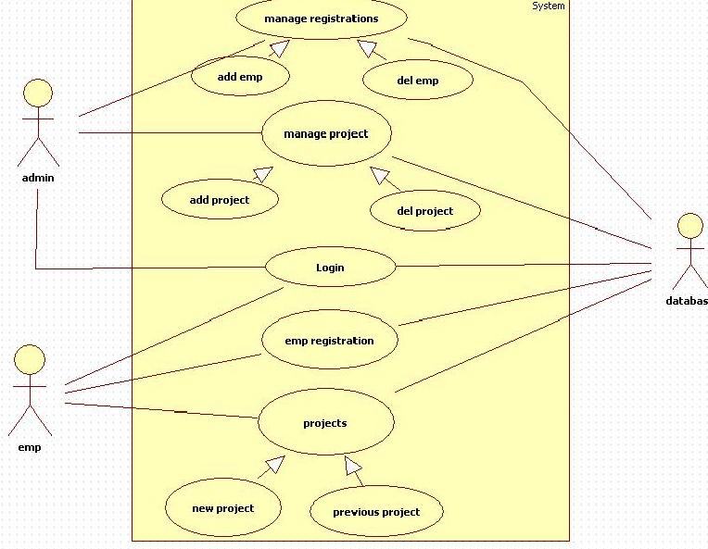

Figure 4.1. Usecase diagram.

4.4.2 SEQUENCE DIAGRAMS
The admin have to login in order check the project details and to identify the risk and provide the measure to eradicate it. The admin can also add and delete the users/employees in order to have control on the system. . (see Figure 4.2).
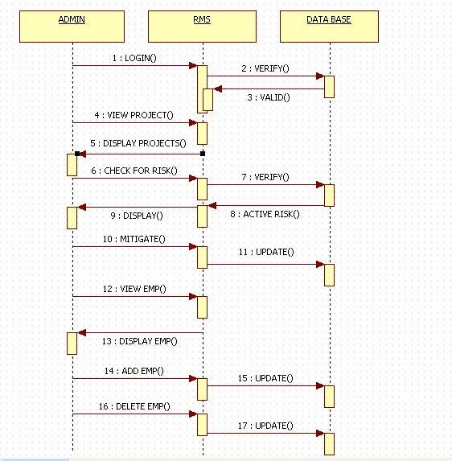

Figure 4.2. Admin sequence diagram.
The user logs into the system using user-id and password provided by the admin. The user can view his previous projects, uploaded by him in recent times .The user/employee can upload a project to know the risks obtained in particular phase, the probability of the risk and to know the measures to mitigate the risk. (see Figure 4.3).
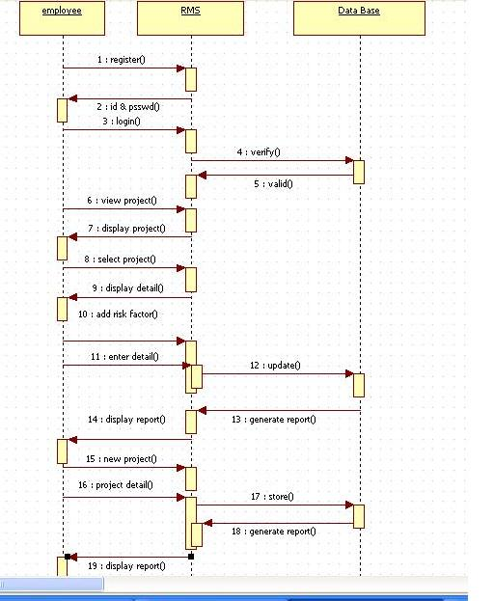

Figure 4.3. Employee sequence diagram.

4.4.3. CLASS DIAGRAM
The class diagram shows the attributes, objects and the methods included in the risk management system .There are different classes present in the system. . (see Figure 4.4).

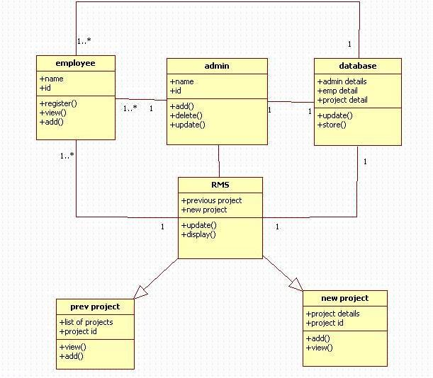

Figure 4.4. Class diagram.

CHAPTER 5

IMPLEMENTATION AND RESULTS

5.1 IMPLEMENTATION OF PROPOSED SYSTEM
Project Setup
First, create a Web project for online System. The project name is Risk Management System. Then, add a data connection for the data source to the project. The data connection is located in the Data Environment of the project Risk Management System.

Site Diagram
A site diagram provides valuable information about the structure of a Web application. It defines the navigation relationships among a set of pages and specifies the pages that appear on the global navigation bar.
Site diagram for Customer:

User.jsp
New customer existing customer

Login: username and password
Openaccount/open accountnew.jsp

User home.jsp

CONTENT DIAGRAM OF PROJECT
User/employee

Risk Management System

Admin

5.2 MODULE DESIGN AND ORGANIZATION

It deals with these modules: Admin , user/employee in the particular organization.
- Admin module

In Admin module, admin have to login in order to add or delete an employee and to view the projects uploaded by the employees to provide measures to the risk identified. The admin after providing the measure , will generate a report to the employee which is retrieved from the database.

- User module

In employee module, it represents services provided by the Risk management System where the user can upload a new project to know the risks in particular phase and to know the measures to mitigate the risk. The employee can view his previous projects also.

5.3METHOD OF IMPLEMENTATION

5.3.1 OUTPUT SCREENS

User pages:

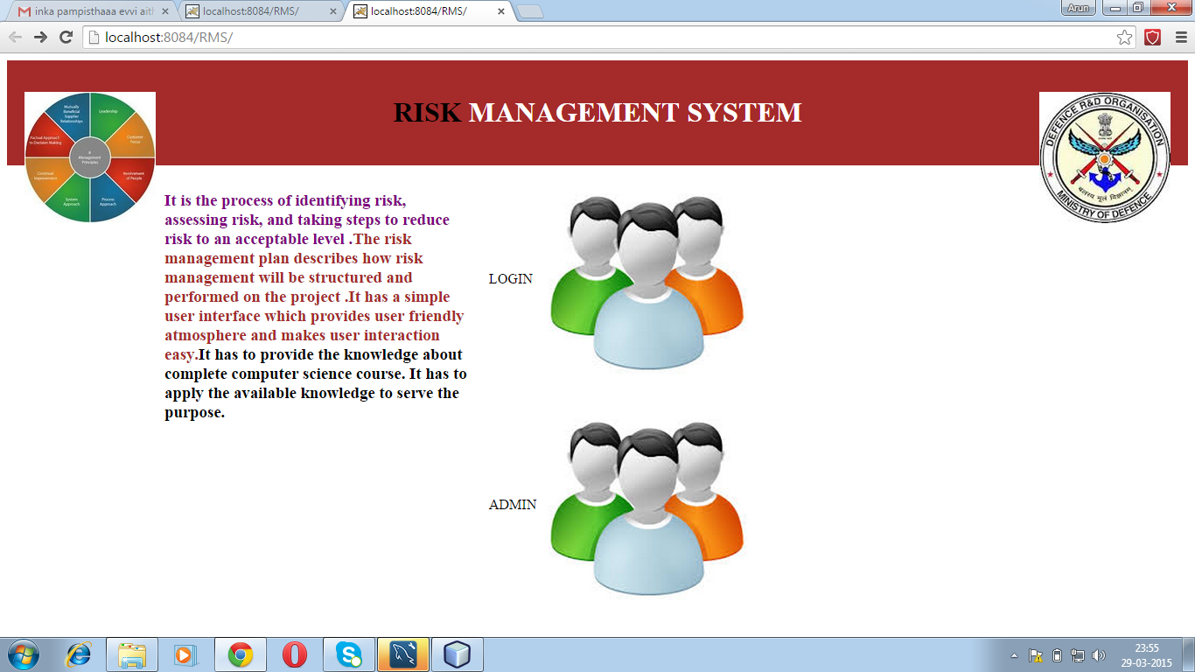

The above screen is the home page of Risk Management System where the login is provided both to the employee and the admin.

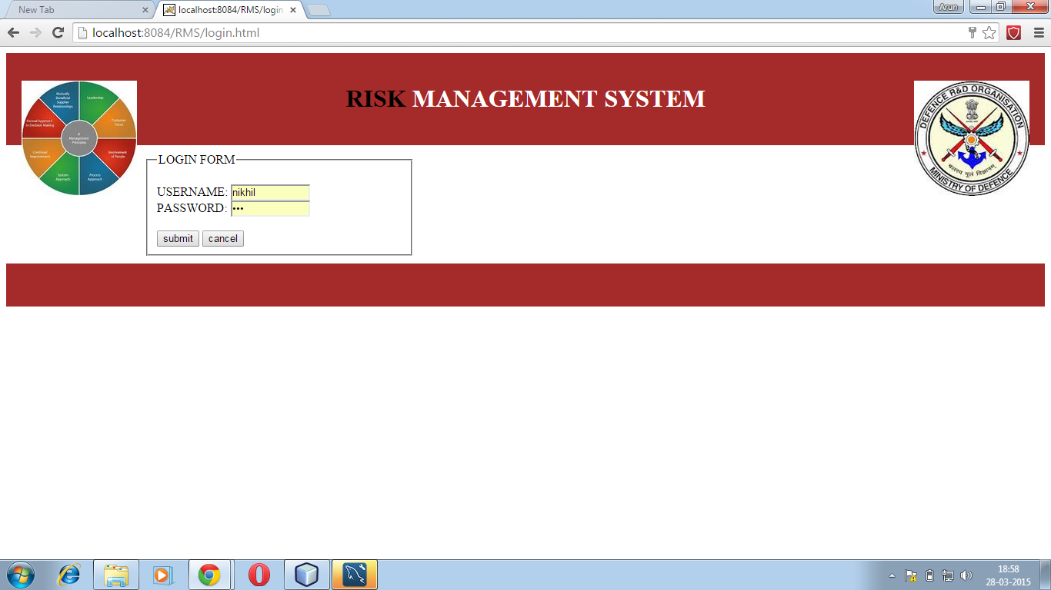

The above screen is the login page for the user to login. User must fill the necessary fields and the validation is done.

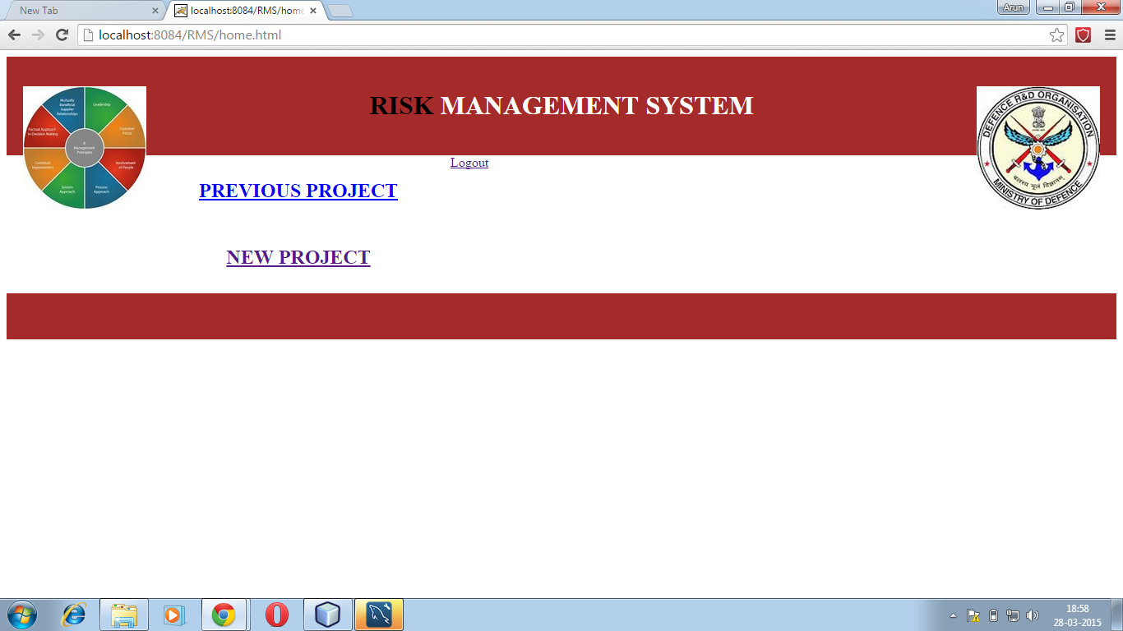

The above screen is the page where the user is provided with the services.

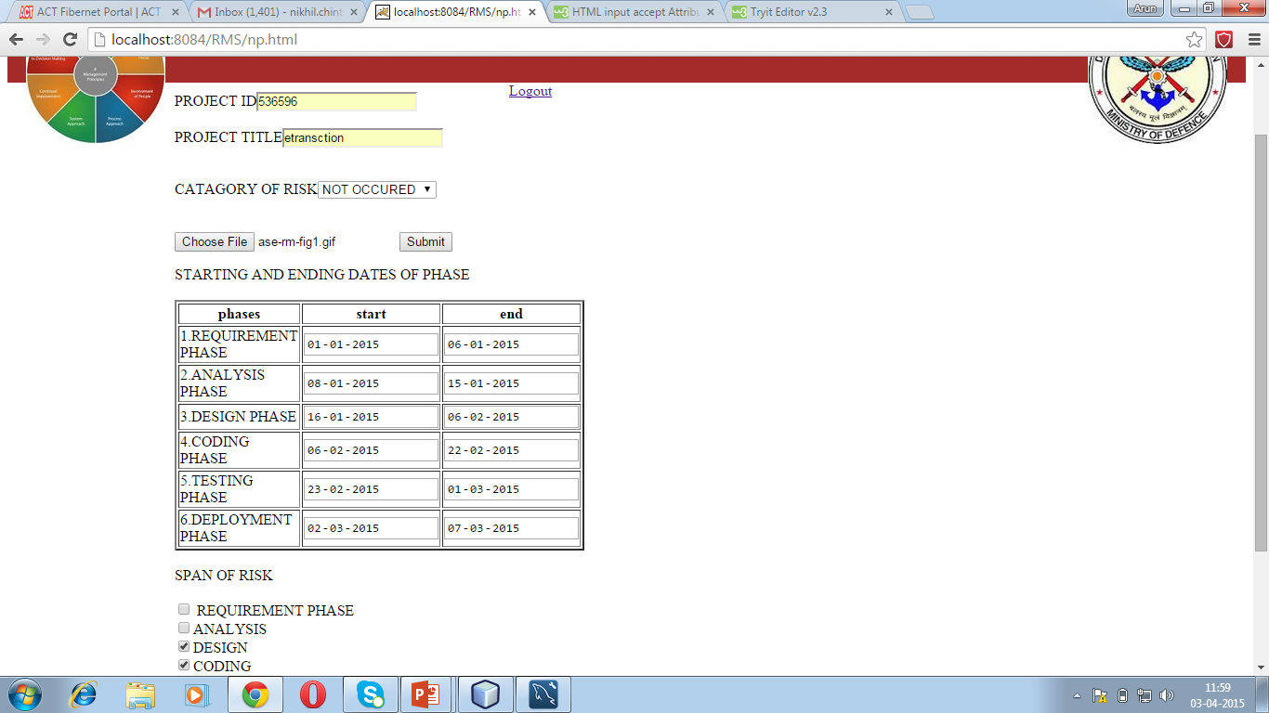

In the above screen,the employee/user will upload his project and fill the details in order to know the measures of the risk identified.

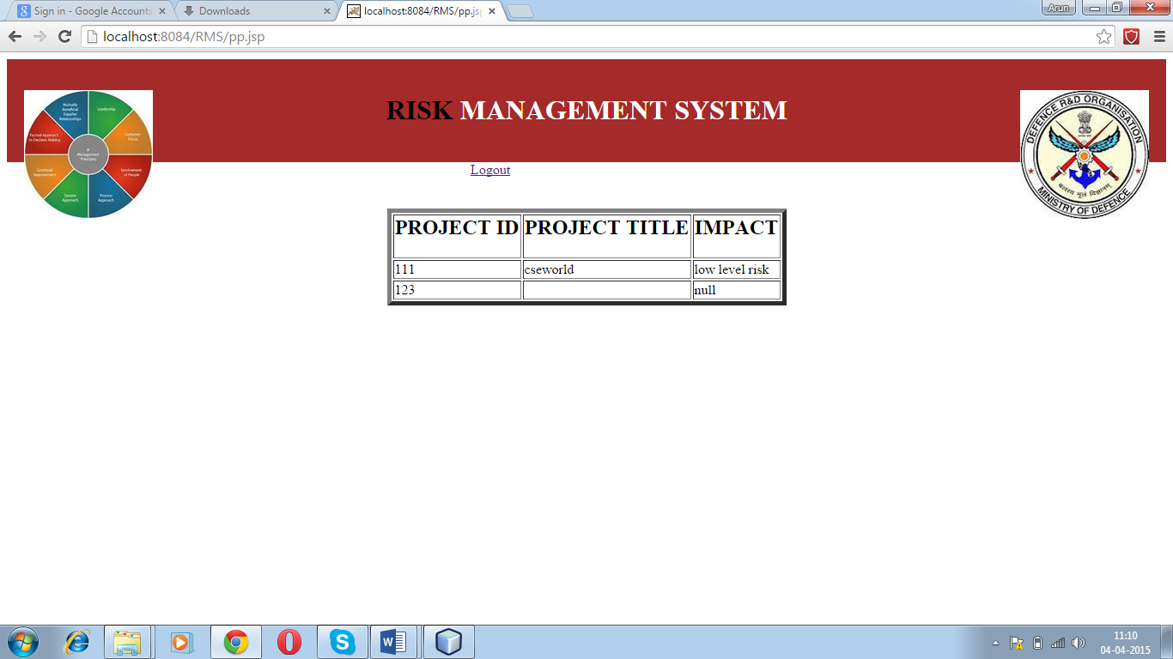

The above screen displays the previous list of projects done by the employee.

Admin pages:

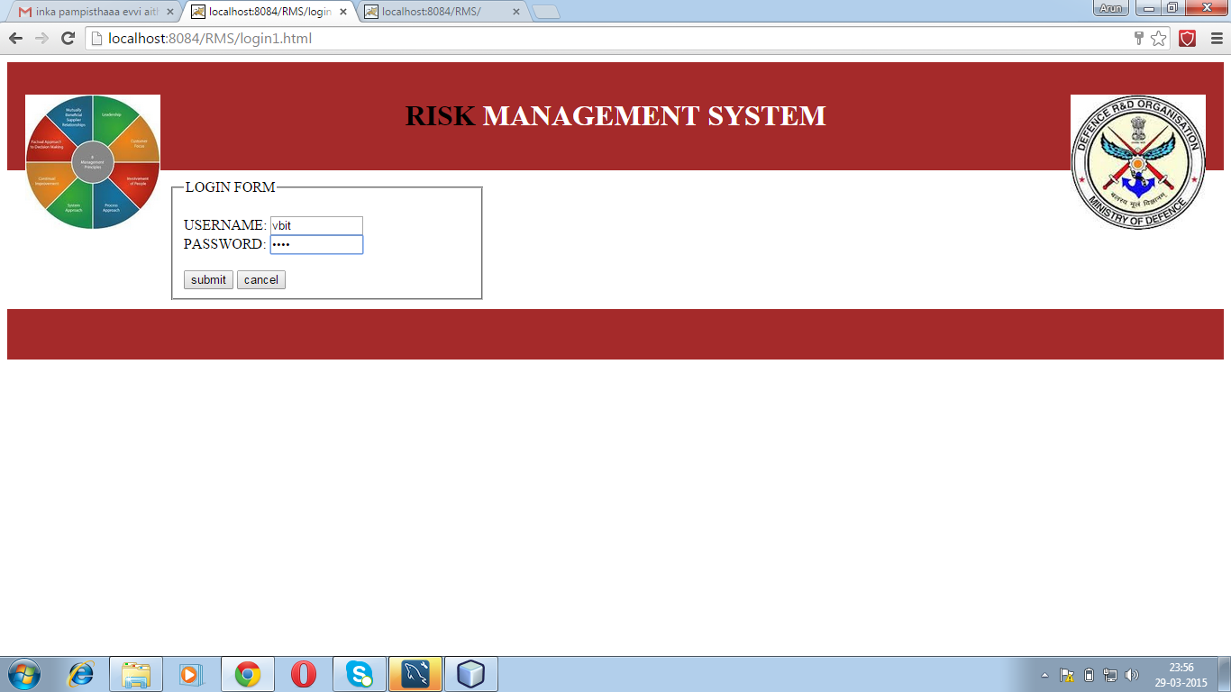

The above screen is the login page of the admin.

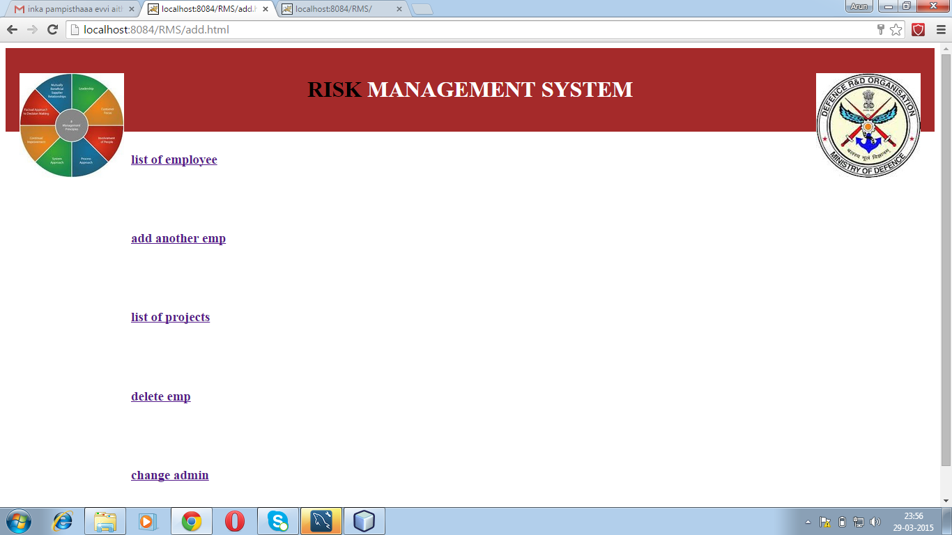

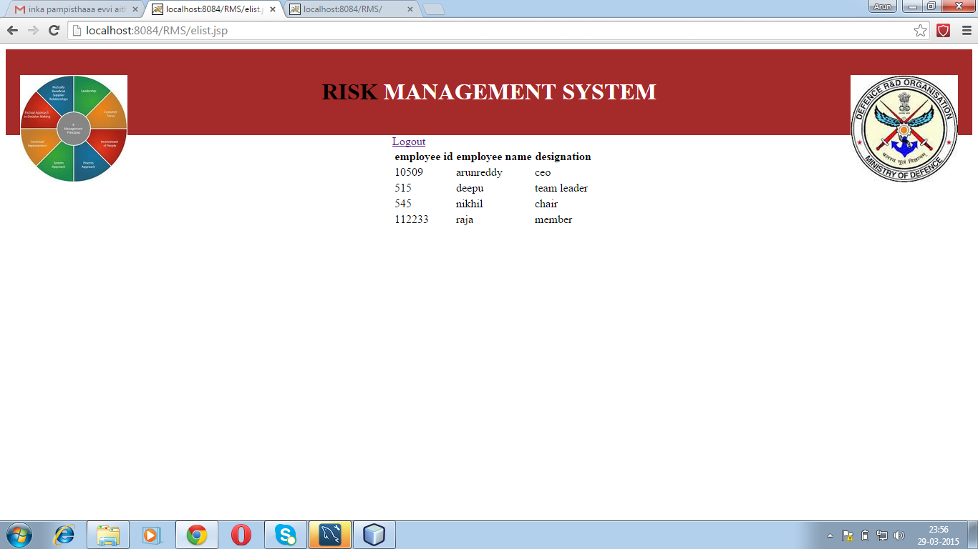

In the above screen, the admin can add an employee by entering his details on to webpage.

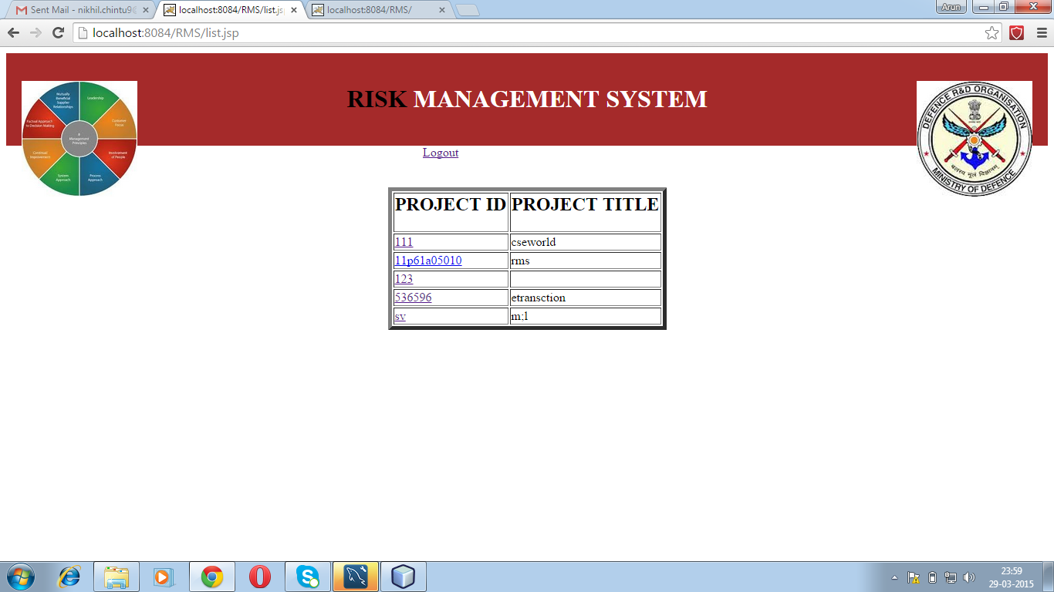

In the above screen the admin can view the list of the projects in the system.

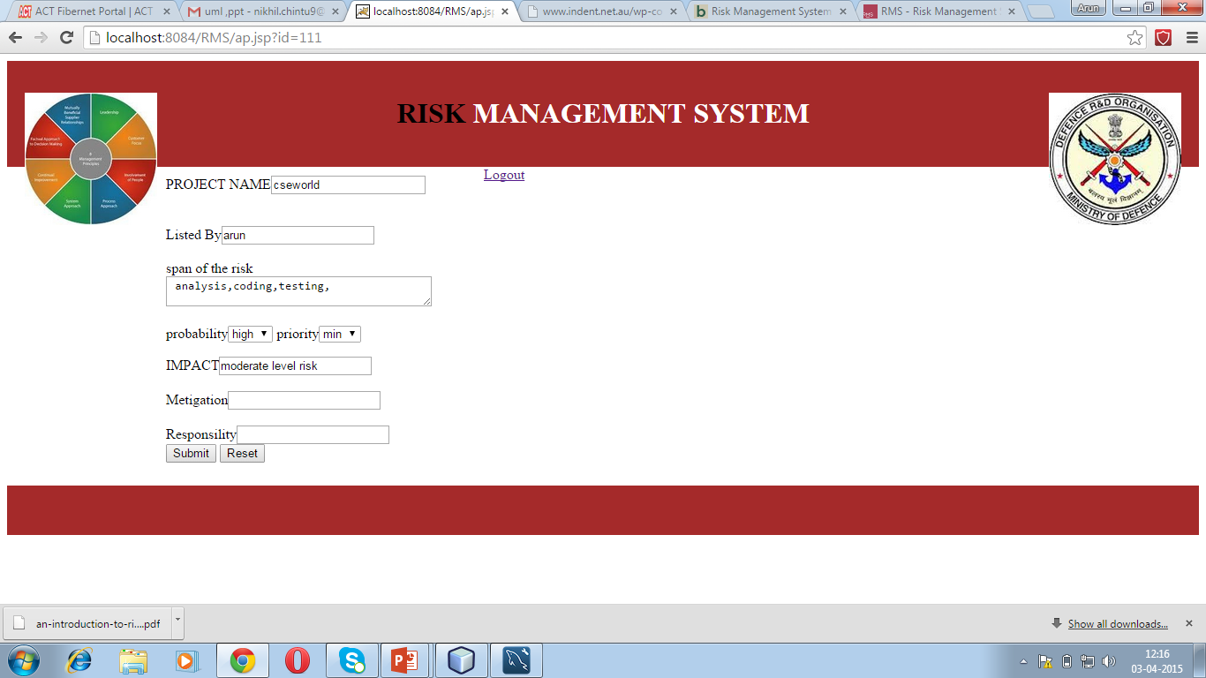

In the above screen, the admin gives the impact and responsibility measures based on the priority and probability of the risk.

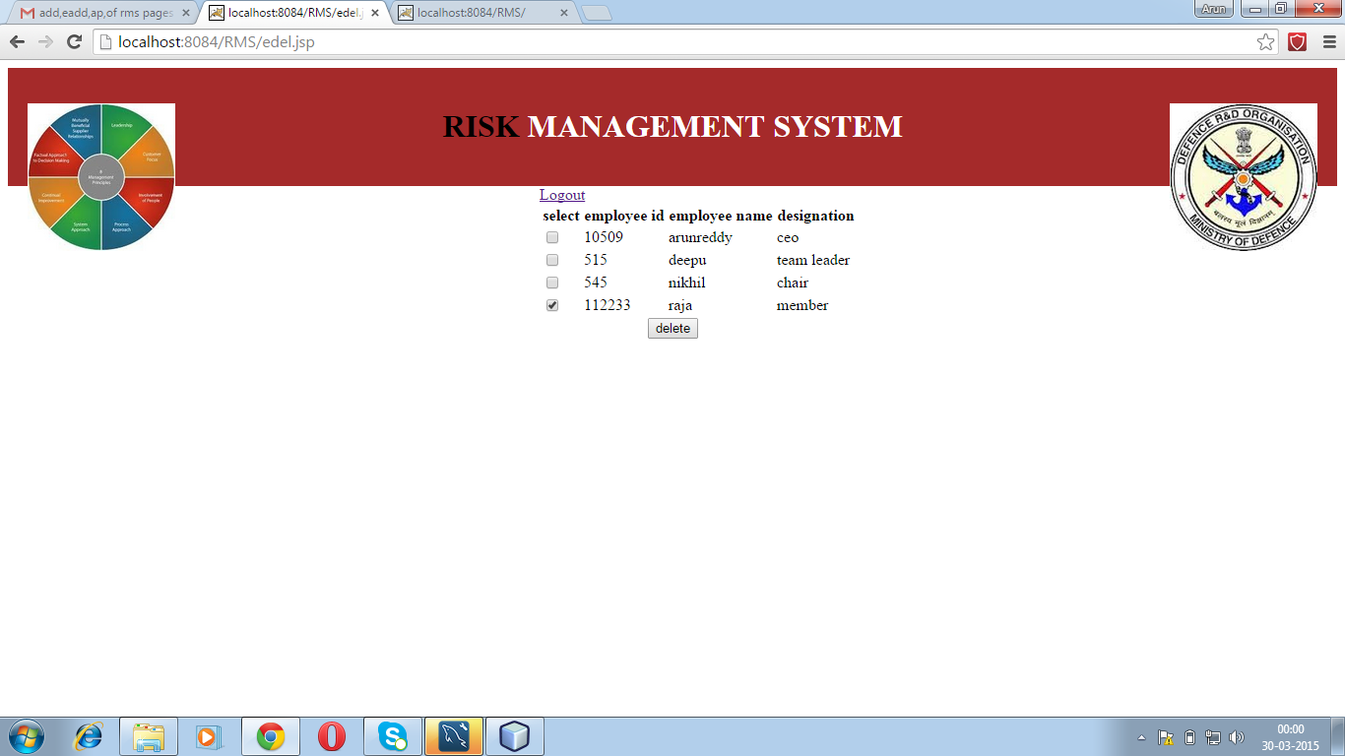

Here in the above screen, the admin can delete the employee from the list of the employees in the system.

CHAPTER 6

TESTING AND VALIDATION

6.1 INTRODUCTION
6.1.1 White-Box testing
White-box testing (also known as clear box testing, glass box testing, transparent box testing and structural testing) tests internal structures or workings of a program, as opposed to the functionality exposed to the end-user. In white-box testing an internal perspective of the system, as well as programming skills, are used to design test cases. The tester chooses inputs to exercise paths through the code and determine the appropriate outputs. This is analogous to testing nodes in a circuit, e.g. in-circuit testing (ICT).
While white-box testing can be applied at the unit, integration and system levels of the software testing process, it is usually done at the unit level. It can test paths within a unit, paths between units during integration, and between subsystems during a system–level test. Though this method of test design can uncover many errors or problems, it might not detect unimplemented parts of the specification or missing requirements.
Techniques used in white-box testing include:
- API testing (application programming interface) – testing of the application using public and private APIs
- Code coverage – creating tests to satisfy some criteria of code coverage (e.g., the test designer can create tests to cause all statements in the program to be executed at least once)
- Fault injection methods – intentionally introducing faults to gauge the efficacy of testing strategies
- Mutation testing methods
- Static testing methods
Code coverage tools can evaluate the completeness of a test suite that was created with any method, including black-box testing. This allows the software team to examine parts of a system that are rarely tested and ensures that the most important function points have been tested. Code coverage as a software metric can be reported as a percentage for:
- Function coverage, which reports on functions executed.
- Statement coverage, which reports on the number of lines executed to complete the test.
100% statement coverage ensures that all code paths, or branches (in terms of control flow) are executed at least once. This is helpful in ensuring correct functionality, but not sufficient since the same code may process different inputs correctly or incorrectly.

6.1.2 Black-box testing
Black-box testing treats the software as a "black box", examining functionality without any knowledge of internal implementation. The tester is only aware of what the software is supposed to do, not how it does it. Black-box testing methods include: equivalence partitioning, boundary value analysis, all-pairs testing, state transition tables, decision table testing, fuzz testing, model-based testing, use case testing, exploratory testing and specification-based testing.
Specification-based testing aims to test the functionality of software according to the applicable requirements. This level of testing usually requires thorough test cases to be provided to the tester, who then can simply verify that for a given input, the output value (or behavior), either "is" or "is not" the same as the expected value specified in the test case. Test cases are built around specifications and requirements, i.e., what the application is supposed to do. It uses external descriptions of the software, including specifications, requirements, and designs to derive test cases. These tests can be functional or non-functional, though usually functional.
Specification-based testing may be necessary to assure correct functionality, but it is insufficient to guard against complex or high-risk situations.
One advantage of the black box technique is that no programming knowledge is required. Whatever biases the programmers may have had, the tester likely has a different set and may emphasize different areas of functionality. On the other hand, black-box testing has been said to be "like a walk in a dark labyrinth without a flashlight."Because they do not examine the source code, there are situations when a tester writes many test cases to check something that could have been tested by only one test case, or leaves some parts of the program untested.
This method of test can be applied to all levels of software testing: unit, integration, system and acceptance. It typically comprises most if not all testing at higher levels, but can also dominate unit testing as well.

6.1.3 Unit testing
Unit testing, also known as component testing, refers to tests that verify the functionality of a specific section of code, usually at the function level. In an object-oriented environment, this is usually at the class level, and the minimal unit tests include the constructors and destructors.
These types of tests are usually written by developers as they work on code (white-box style), to ensure that the specific function is working as expected. One function might have multiple tests, to catch corner cases or other branches in the code. Unit testing alone cannot verify the functionality of a piece of software, but rather is used to assure that the building blocks the software uses work independently of each other.
Unit testing is a software development process that involves synchronized application of a broad spectrum of defect prevention and detection strategies in order to reduce software development risks, time, and costs. It is performed by the software developer or engineer during the construction phase of the software development lifecycle. Rather than replace traditional QA focuses, it augments it. Unit testing aims to eliminate construction errors before code is promoted to QA; this strategy is intended to increase the quality of the resulting software as well as the efficiency of the overall development and QA process.
Depending on the organization's expectations for software development, unit testing might include static code analysis, data flow analysis metrics analysis, peer code reviews, code coverage analysis and other software verification practices.
6.1.4 Integration testing
Integration testing is any type of software testing that seeks to verify the interfaces between components against a software design. Software components may be integrated in an iterative way or all together ("big bang"). Normally the former is considered a better practice since it allows interface issues to be located more quickly and fixed.
Integration testing works to expose defects in the interfaces and interaction between integrated components (modules). Progressively larger groups of tested software components corresponding to elements of the architectural design are integrated and tested until the software works as a system.

6.1.5 System testing
System testing tests a completely integrated system to verify that it meets its requirements.
In addition, the software testing should ensure that the program, as well as working as expected, does not also destroy or partially corrupt its operating environment or cause other processes within that environment to become inoperative (this includes not corrupting shared memory, not consuming or locking up excessive resources and leaving any parallel processes unharmed by its presence).[citation needed]

6.1.6 Acceptance testing
At last the system is delivered to the user for Acceptance testing.

6.2 DESIGN OF TEST CASES AND SCENARIOS
 | test scenario | Test Design | Input Data | Expected Result | Actual Result
1 | check the working of Risk Management System login page | Launch Net Beans and run Home page |  | login page should be displayed | login page is displayed
2 |  | enter valid user id and invalid password |  | error message page should be displayed saying "invalid password. please try again" | error message page is displayed saying "invalid password. please try again"
3 |  | Check for the consistency, alignment, spelling mistakes, and other cosmotic issues |  | The contents of the Page should be properly aligned, consistent, without spelling mistakes | The contents of the Page is properly aligned, consistent without spelling mistakes
4 |  | Focus on 'Home' link & press [Tab] continuously. |  | Tab order should go with all the fields according to their occurrences | Tab order is according to their occurrences
5 | Check the working of user login page | Enter valid userid and valid password corresponding to a user. | user id: nikhil password: 545 | Employee home page should be displayed. | Employee home page should be displayed.
6 | Check the working of new project hyperlink. | Enter the details of the project and upload it and click submit. | Title: cse  Id:454  Phase: design | The details should be stored in to the database. | The project details are stored in the database.
7 | Check the working of previous project hyperlink. |  |  | The previous projects done by the user should be displayed. | The previous projects done by the user should be displayed.
8 | Check the working of the admin login page. | Enter vaild username, vaild password  and click on submit | Username:vbit password:vbit and Submit button. | Functionalities performed by the admin should be displayed. | Functionalities performed by the admin should be displayed.
9 |  | Click on list of employees |  | List of employees using the system should be displayed. | List of employees using the system should be displayed.
10 |  | Click on list of projects. |  | List of projects in the system should be displayed. | List of projects in the system should be displayed.
11 |  | Click on add employee. | Employee name: deepika  Employee id :515  Password:515 | Employee should be add and stored in | Home page is displayed
12 |  | click on delete employee. | Select the employee.and click on delete button. | The employee list should updated after deleting the selected employee. | The employee list should updated after deleting the selected employee.
13 |  | Click on the change admin. | Enter the details  Admin: arun  Password: 509 | Admin table should be updated and access to previous admin should be disconnected. | Admin table should be updated and access to previous admin should be disconnected.
14 |  | Click on the project name | Give the probability and measures. | The database should be updated and the report should be generated at users end. | The database should be updated and the report should be generated at users end.
15 | Click on logout. |  |  | The admin or user should come out of the home page and index page should be displayed. | The admin or user should come out of the home page and index page should be displayed.

6.3 VALIDATION

6.3.1 Validation for Requirements

RISKDETAILS:

<%@page contentType="text/html" pageEncoding="UTF-8"%>

<%@page import="java.sql.*"%>

<%

String pid=request.getParameter("pid");

String pname=request.getParameter("pname");

String cor=request.getParameter("cor");

String rstart=request.getParameter("rstart");

String rend=request.getParameter("rend");

String astart=request.getParameter("astart");

String aend=request.getParameter("aend");

String dstart=request.getParameter("dstart");

String dend=request.getParameter("dend");

String cstart=request.getParameter("cstart");

String cend=request.getParameter("cend");

String tstart=request.getParameter("tstart");

String tend=request.getParameter("tend");

String dpstart=request.getParameter("dpstart");

String dpend=request.getParameter("dpend");

String spanofrisk1=request.getParameter("spanofrisk1");

String spanofrisk2=request.getParameter("spanofrisk2");

String spanofrisk3=request.getParameter("spanofrisk3");

String spanofrisk4=request.getParameter("spanofrisk4");

String spanofrisk5=request.getParameter("spanofrisk5");

String spanofrisk6=request.getParameter("spanofrisk6");

String name=(String)session.getAttribute("name");

String sp1,sp2,sp3,sp4,sp5,sp6;

if(spanofrisk1!=null)

{

sp1="yes";

}

else

{

sp1="no";

}

if(spanofrisk2!=null)

{

sp2="yes";

}

else

{

sp2="no";

}

if(spanofrisk3!=null)

{

sp3="yes";

}

else

{

sp3="no";

}

if(spanofrisk3!=null)

{

sp3="yes";

}

else

{

sp3="no";

}

if(spanofrisk4!=null)

{

sp4="yes";

}

else

{

sp4="no";

}

if(spanofrisk5!=null)

{

sp5="yes";

}

else

{

sp5="no";

}

if(spanofrisk6!=null)

{

sp6="yes";

}

else

{

sp6="no";

}

String ps=request.getParameter("ps");

Class.forName("com.mysql.jdbc.Driver");

Connection conn = null;

conn = DriverManager.getConnection("jdbc:mysql://localhost:3306/rms","root", "root");

Statement stmt = conn.createStatement();

//String str="insert into riskdetails WHERE user='"+name+"' values('"+pid+"','"+pname+"','"+cor+"','"+rstart+"','"+rend+"','"+astart+"','"+aend+"','"+dstart+"','"+dend+"','"+cstart+"','"+cend+"','"+tstart+"','"+tend+"','"+dpstart+"','"+dpend+"','"+sp1+"','"+sp2+"','"+sp3+"','"+sp4+"','"+sp5+"','"+sp6+"','"+ps+"')";

String str= "UPDATE riskdetails SET projectid='"+pid+"', title='"+pname+"',category='"+cor+"',rstart='"+rstart+"',rend='"+rend+"',astart='"+astart+"',aend='"+aend+"',dstart='"+dstart+"',dend='"+dend+"' ,cstart='"+cstart+"',cend='"+cend+"',tstart='"+tstart+"',tend='"+tend+"',dpstart='"+dpstart+"',dpend='"+dpend+"',sr='"+sp1+"',sa='"+sp2+"',sd='"+sp3+"',sc='"+sp4+"',st='"+sp5+"',sdp='"+sp6+"',specific='"+ps+"' WHERE user='"+name+"'";

stmt.executeUpdate(str);

//stmt.close();

//conn.close();

response.sendRedirect("home.html");

%>

USERJSP:

<%@page contentType="text/html" pageEncoding="UTF-8"%>

<%@page import="java.sql.*"%>

<%

try

{

String uname=request.getParameter("username");

String psswrd=request.getParameter("password");

String sql1="select * from login where username='"+uname+"' and password='"+psswrd+"'";

Class.forName("com.mysql.jdbc.Driver").newInstance();

Connection conn = null;

conn = DriverManager.getConnection("jdbc:mysql://localhost:3306/rms","root", "root");

Statement stmt = conn.createStatement();

ResultSet rs=stmt.executeQuery(sql1);

if(rs.next())

{

session.setAttribute("name", uname);

response.sendRedirect("home.html");

}

else

{

out.println("<html><body><script type=\"text/javascript\">");

out.println("confirm('INVALID USERNAME or PASSWORD');");

out.println("</script></body></html>");

}

}

<%

Coonection:

Class.forName("com.mysql.jdbc.Driver");

Connection conn = null;

String id=request.getParameter("id");

conn = DriverManager.getConnection("jdbc:mysql://localhost:3306/rms","root", "root");

Statement stmt = conn.createStatement();

String str="select title,user,sr,sa,sd,sc,st,sdp from riskdetails where projectid='"+id+"'";

ResultSet rs=stmt.executeQuery(str);

%>

CHAPTER 7

CONCLUSION AND FUTURE ENHANCEMENT

Risk Management System is a web application which is restricted to a particular organization where it builds a communication bridge between the employees to resolve the problems and issues like risks in a project. This system completely provides security as only authorized person can access the services provided by it. A risk management system is a ground step where the projects can be handled and observed to get the efficient output.

The future enhancement of this project is , as it is constructed as one category, in future in can be expanded into multiple levels and multiple categories according to the numbers of roles present in the particular organization. The chance in increasing the efficiency and readability may be more.
BIBLIOGRAPHY

- http://www.phe.gov/about/amcg/toolkit/Documents/risk-management.pdf
- http://en.wikipedia.org/wiki/Risk_management
- www.w3schools.com
- Java.sun.com tutorials
- http://agile.csc.ncsu.edu/SEMaterials/RiskManagement.pdf
- Object-Oriented Software Engineering Using UML, Pattern and Java Second Edition by Bernd Bruegge, Allen H.Duetoit.

